Q2 –

Time taken with PutMerge 45799milliseconds

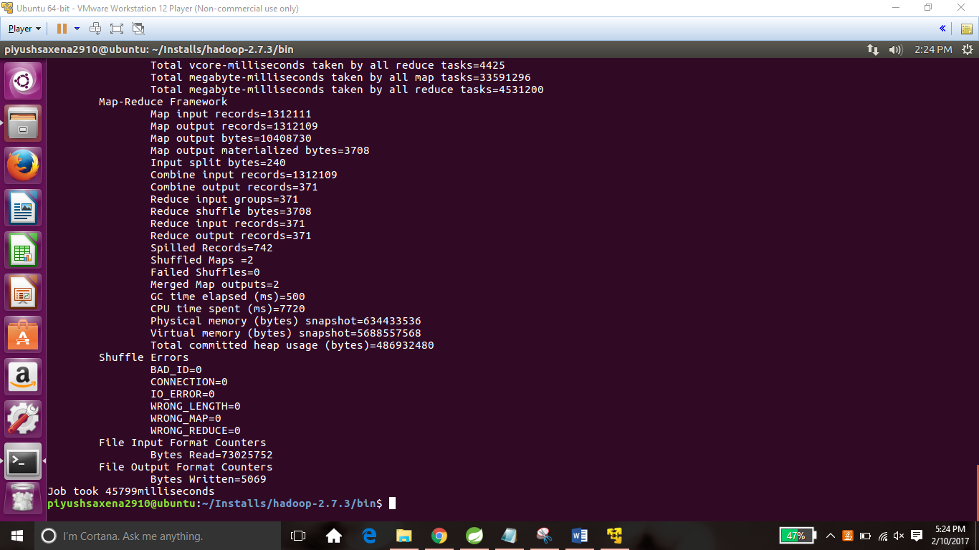

Time taken without PutMerge 49650milliseconds

